iPRODUCE Competition 1
Solutions and services for the prosumer competition
Entry technical description
template
This project has received funding from the European Union’s Horizon 2020 research and innovation programme under Grant Agreement no. 870037.
This project has received funding from the European Union’s Horizon 2020 research and innovation programme under Grant Agreement no. 870037

DISCLAIMER

This document contains information and material that is the copyright of iPRODUCE consortium parties and may not be reproduced or copied without consent.

© The information and material included in this document are the responsibility of the authors and do not necessarily reflect the opinion of the European Union. Neither the European Union institutions and bodies nor any person acting on behalf may be held responsible for the use that may be made of the information and material contained herein.
© iPRODUCE Consortium, 2020-2022.
Reproduction is authorized provided the present document and authors are acknowledged

iPRODUCE ● Grant Agreement: 870037 ● Innovation Action ● 2020 – 2022 | Duration: 36 months
Topic: DT-FOF-05-2019: Open Innovation for collaborative production engineering (IA)

PROPOSAL TEMPLATE - INSTRUCTIONS

Please read carefully before starting your proposal:
Please use this template to prepare the technical description of your entry. It has been organised to ensure that the important aspects of your entry are measurable with respect to the evaluation criteria. Sections 1 to 4 of this template each correspond to an evaluation criterion.
The structure of this template must be followed when preparing your entry. Contestants using another template/ document structure will be automatically disqualified. Only those entries that successfully address all the required aspects considered in the template will have the opportunity to be awarded.
The page limit for the proposal is 5 pages (not including the cover and summary of the entry pages). The suggested number of pages at the top of each section (highlighted yellow) is flexible and provides guidance to not exceed the maximum number of pages (5).
Figures and tables are allowed and must be included within this page limit. The minimum font size allowed is 11 points (note: tables can use font size 10 points). The page size is A4, and all margins (top, bottom, left, right) should not be changed from their current setting. Paragraph spacing should be a minimum 0pt before/ after, and 1pt line spacing. It is recommended to use Arial as the font style and black as the font colour to facilitate readability.
If you attempt to upload a proposal longer than the specified limit, excess pages will be made invisible, and will not be taken into consideration in the evaluation.
Please delete this page when submitting the entry. Delete the guidance/ information text in blue in each section and any footnotes.

COVER PAGE

ENTRY INFORMATION AND CONTESTANTS
Acronym
Title / Name

NOTE: Please define an acronym and title/name for your idea.

PARTNER | PARTNER NAME | COUNTRY
Partner 1
Partner 2
(if applicable)
Partner 3
(if applicable)

NOTE: Maximum of three partners per entry; please delete unused lines.

SUMMARY OF THE ENTRY
NOTE: MAXIMUM OF 1 PAGE
Provide a full public summary of the entry (idea/ solution)) being submitted that can be published if the entry is awarded.

CONCEPT
NOTE: Up to 3 pages; Figures and Tables to support description are accepted.

Concept and objectives
Describe the overall concept of the idea/solution envisioned and objectives to be achieved.
Also consider including:
- At what stage of development the idea/ solution is.
- How co-design and co-development principles are part of the idea.
- How your idea is novel and address a new or existing need.
- If it addresses existing needs, how the idea is innovative.
- Expected quantitative and qualitative outcomes.

Implementation
Describe the plan for implementing the idea/solution, both during the time with support from iPRODUCE and after.
Also consider including:
- The specific activities that will be implemented and time required.
- Relevant milestones.
- Expected challenges and barriers, both during the time with support from iPRODUCE and after.
- Materials required to implement the idea/ solution. Describe as detailed as possible the materials and related costs, including those to be covered by the monetary prize (Note: Mandatory item)

IMPACT
NOTE: Up to 1.5 pages; Figures and Tables to support description are accepted.
Describe the overall socio-economic impact of the project. Include also:
- The social impact, relevance and benefits of your idea.
- The market and commercial potential of the idea.
- Key requirements for commercial success.
- Potential to scale and be replicated.

LINK TO IPRODUCE
NOTE: Up to 1 page.
Describe the overall link to the iPRODUCE project. Include also:
- Extent to which the proposal can be linked to the objectives of iPRODUCE.
- Extent to which iPRODUCE can provide added value to the proposed idea/ solution.

MOTIVATION
NOTE: Up to ½ page.
Describe the overall motivation to participate in the competition. Include also:
- The motivation behind the proposed idea/ solution.
- The motivations and expectations in regard to your participation in the competition.

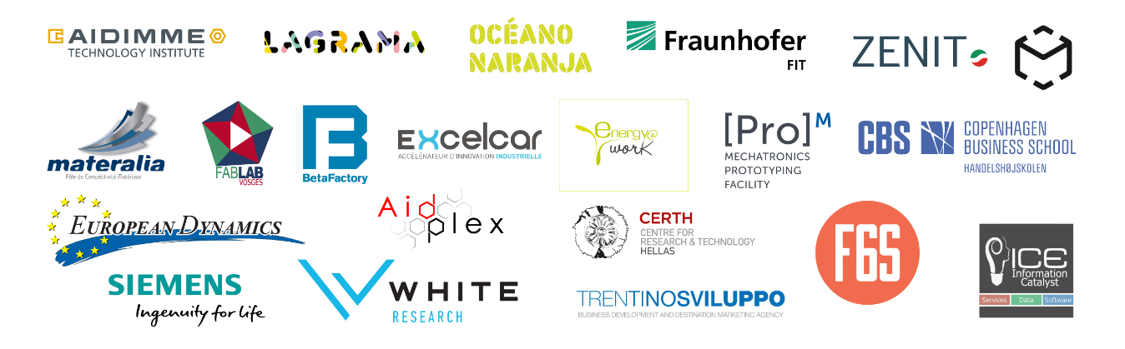
This project has received funding from the European Union’s Horizon 2020 research and innovation programme under Grant Agreement no. 870037.

