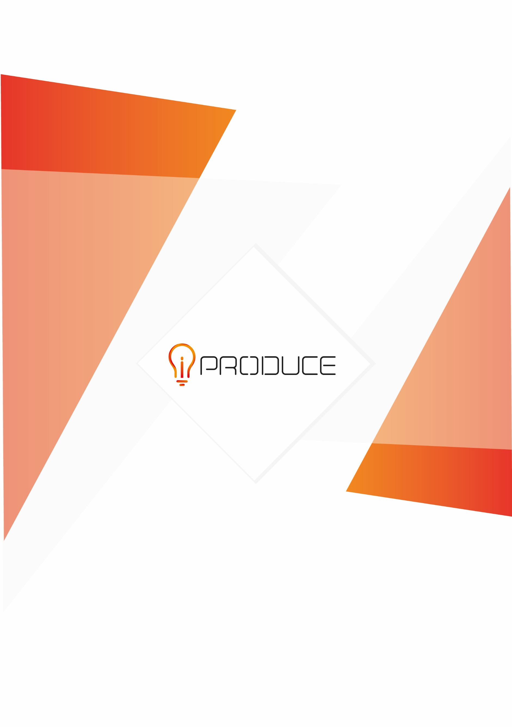
This project has received funding from the European Union’s Horizon 2020 research and innovation programme under Grant Agreement no. 870037.
This project has received funding from the European Union’s Horizon 2020 research and innovation programme under Grant Agreement no. 870037
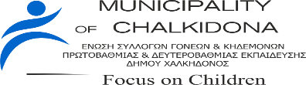
iPRODUCE Open Competition
“3D Collaborative Manufacturing in Education & Culture”
Application File
March 2022
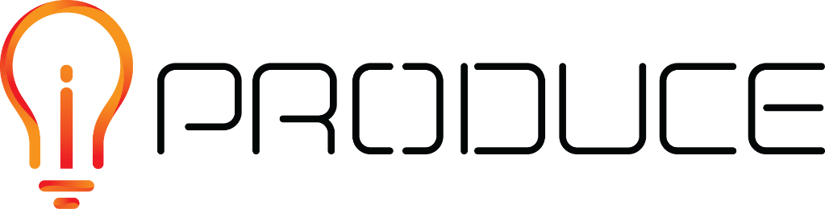
DISCLAIMER

This document contains information and material that is the copyright of iPRODUCE consortium parties and may not be reproduced or copied without consent.

© The information and material included in this document are the responsibility of the authors and do not necessarily reflect the opinion of the European Union. Neither the European Union institutions and bodies nor any person acting on behalf may be held responsible for the use that may be made of the information and material contained herein.
© iPRODUCE Consortium, 2020-2022.
Reproduction is authorized provided the present document and authors are acknowledged

iPRODUCE ● Grant Agreement: 870037 ● Innovation Action ● 2020 – 2022 | Duration: 36 months
Topic: DT-FOF-05-2019: Open Innovation for collaborative production engineering (IA)

Table of contents
1. Introduction 1
1.1. Competition objectives 1
1.2. Concept description 2
1.3. Challenge ideas 2
Challenge idea #A: 3
Challenge idea #B: 3
1.4. Competition Requirements 4
1.5. Participants 4
1.6. Winners 5
1.6.1. Winners 5
1.6.2. Prize & Awards 5
1.7. Competition deadlines 7
2. Application Form 8
2.1. Presentation of the candidate 8
2.2. Description of the idea 8
2.3. Current status of technology in schools 8
2.4. Value and impact of the idea related to iPRODUCE project 8
2.5. Willingness/motivation 8
2.6. Stage of development 9
2.7. Contact details of the applicant 9
2.8. Other terms and conditions 9
3. Submission and evaluation 10
3.1. Submission of applications 10
3.2. Evaluation process 10
3.3. Announcement of results 10
4. Contact and information 11

Introduction
The Information Technologies Institute (ITI) of the Centre for Research and Technology Hellas (CERTH) in collaboration with the start-up AidPlex and the Union of Parents & Guardians Association, of Primary & Secondary Education of the Municipality of Chalkidona, conduct an open student competition, within the framework of the implementation of the European project iPRODUCE.
In particular, through the competition, an innovative way of lifelong learning education approach is promoted, by utilizing the laboratory infrastructures of the Additive Manufacturing Unit (AMU) of CERTH/ITI and AidPlex, enabling the students of the 5th and 6th grade of Elementary Schools and of all the grades of Middle Schools, to come closer to cutting-edge technologies. Specifically, the competition encourages student’s engagement in the creation and manufacturing of real objects, by incorporating 3D Printing and Augmented & Virtual Reality (AR/VR) technologies, with relation to “3D Collaborative Manufacturing in Education and Culture”.

Competition objectives
- The competition aims to:

- contribute to the cultural education of Elementary or Middle school students, through 3D collaborative manufacturing activities

  - encourage the participation of schools/students, allowing for creative ideas and innovative solutions to be explored and implemented, by following the principles of co-design and co-development

- The completion aims to:
- to support winners in the collaborative design and development of prototypes

- to reach further stages of prototype development and implementation of their ideas

- by incorporating 3D printing and AR/VR technologies

Concept description
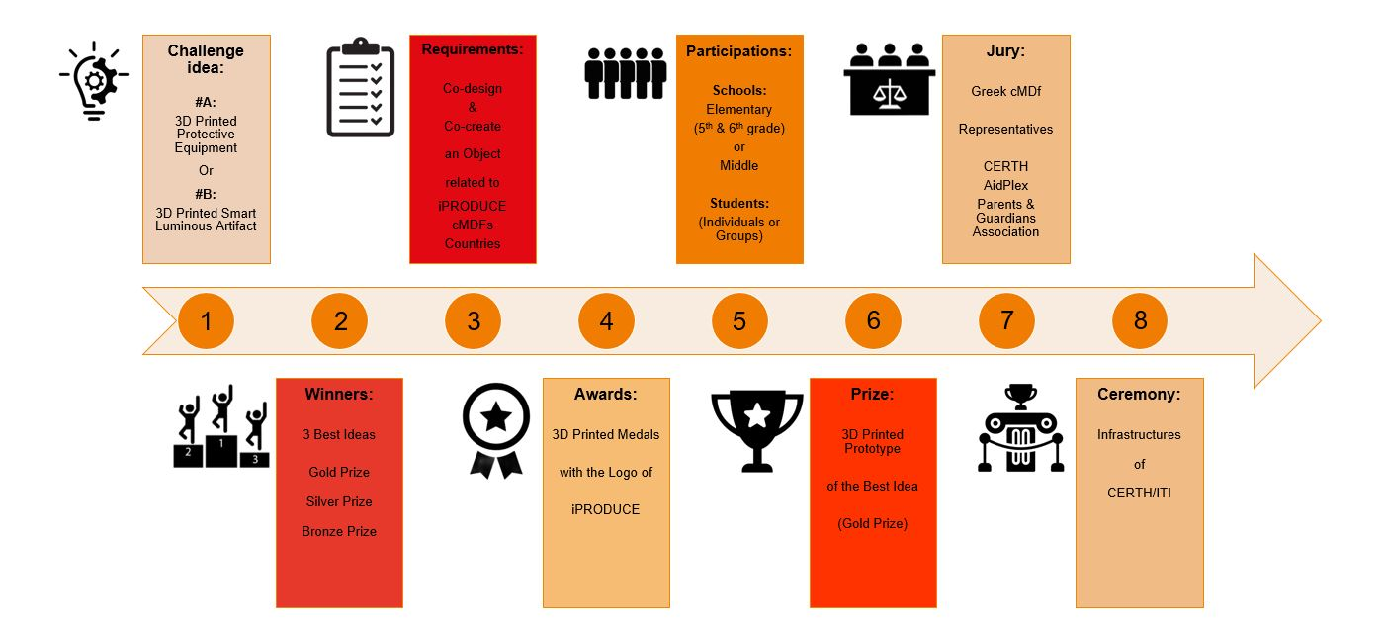

Challenge ideas
- The participants are invited to:

- select one of the proposed challenge ideas

- co-create and co-design an object, related to a country and culture of their choice

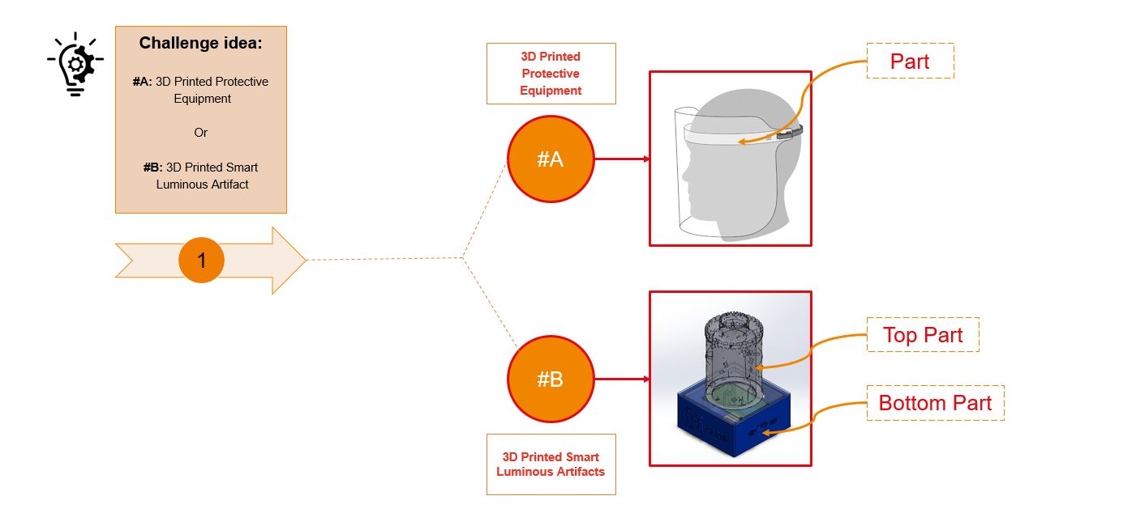

Challenge idea #A:
Design of 3D Printed Protective equipment (e.g. face shields) for COVID-19 protection
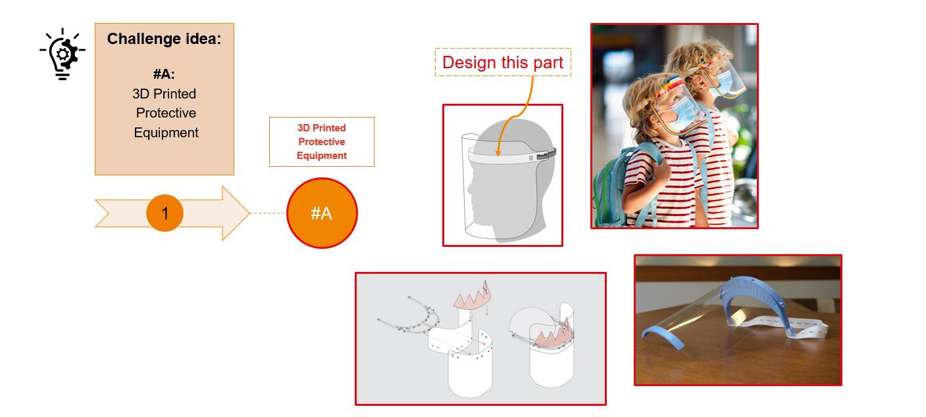

Challenge idea #B:
Design of 3D Printed Smart Luminous Artifact
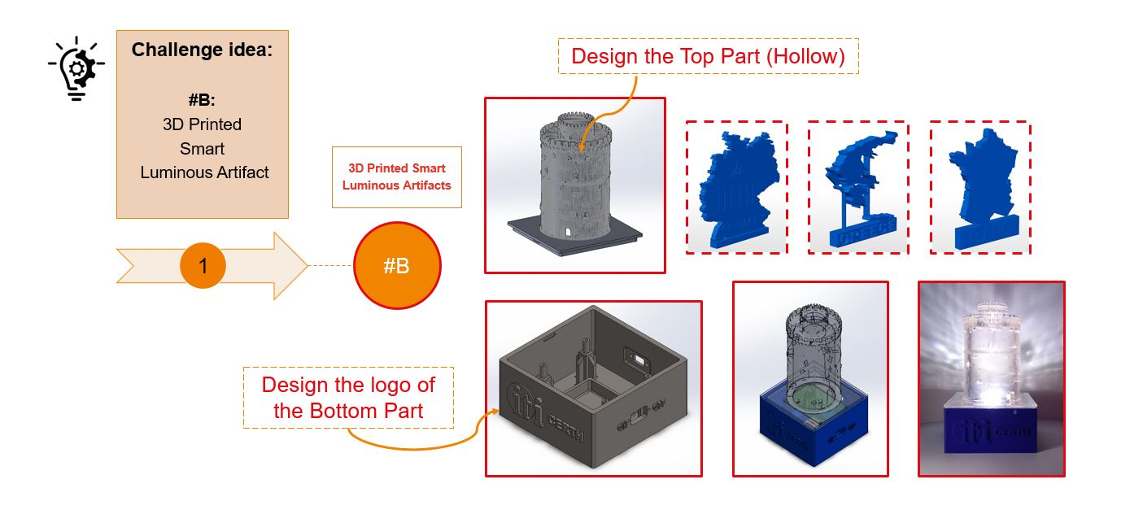

Competition Requirements
- The participants are invited to:

- Select between (#A) and (#B) challenge ideas

- Design a sketch of a 3D model (in paper), in which will appear features of one of the following six European countries of iPRODUCE cMDFs:
- Denmark
- France
- Germany
- Greece
- Italy
- Spain

- Add features related to the culture of the selected country (e.g. flags, monuments, patterns, logos, text)

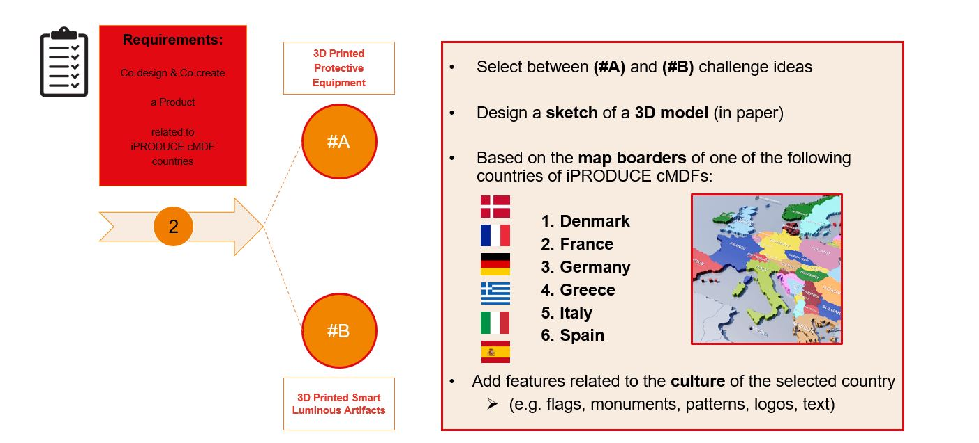

Participants
- The participation in the competition is free of charge

- The possible entries for the competition can be:

- Schools of the Region of Central Macedonia, of Greece
  - Elementary Schools (5th & 6th grade) or
  - Middle Schools (all grades)

- Students of Schools:
  - Individual submissions or
  - Group of students

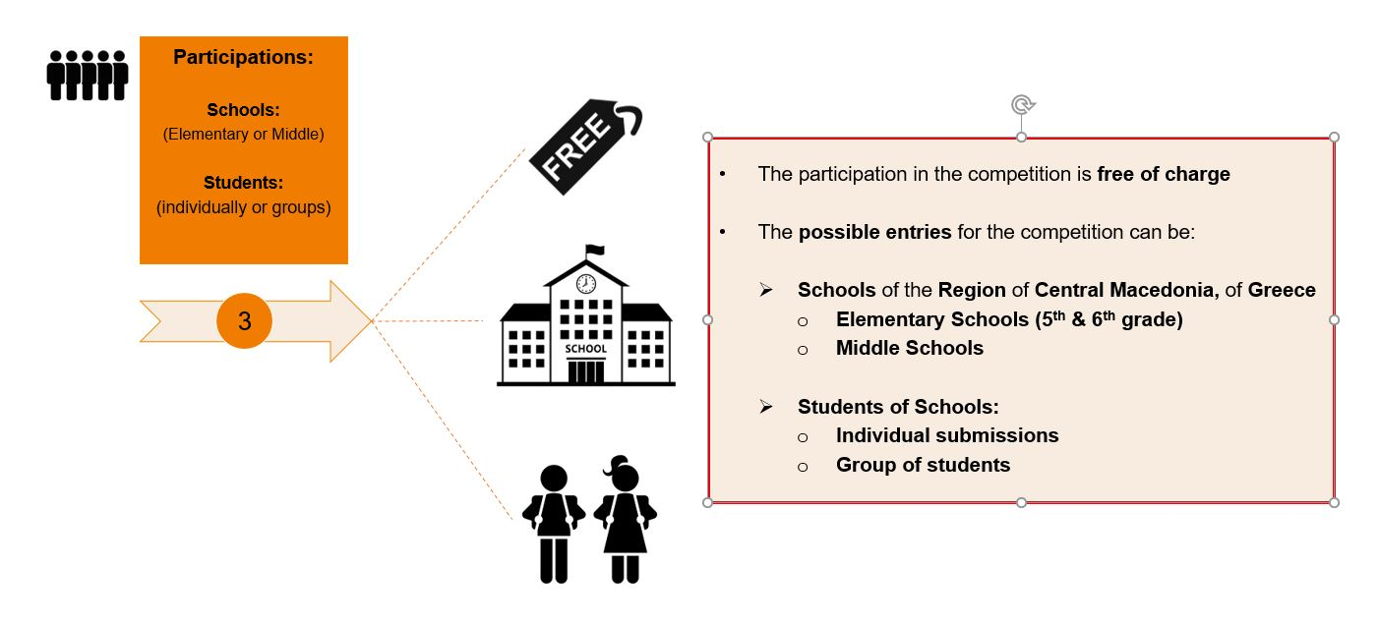

Winners

Winners
- Based on the innovation of the idea, three prizes: the Gold, the Silver and the Bronze, will be distributed to the school/students of the 1st, 2nd, and 3rd place, accordingly.
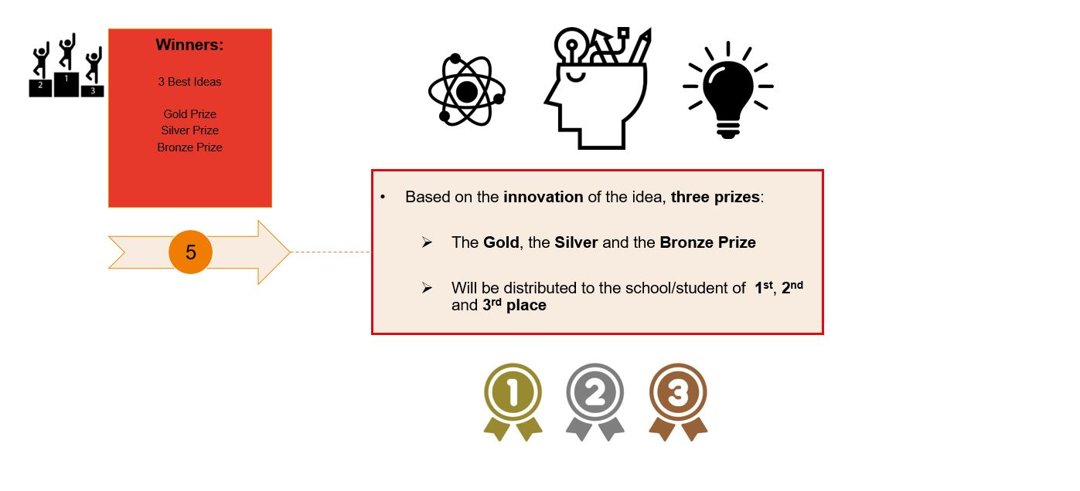

Prize & Awards
- All the students of the three schools that will be the winners of the competition, will receive as an award 3D printed medals (gold, silver, bronze), with engraved logo of iPRODUCE project.

- The best idea (1st prize) will be manufactured using diverse 3D printing technologies.

- The students will have the chance to:

- Have a real-time demonstration of 3D printing process

- Have a guided tour in the infrastructures of Additive Manufacturing Unit (AMU) of CERTH/ITI and of AidPlex

- Utilize the OpIS platform of iPRODUCE, in order to co-create and evaluate their idea.

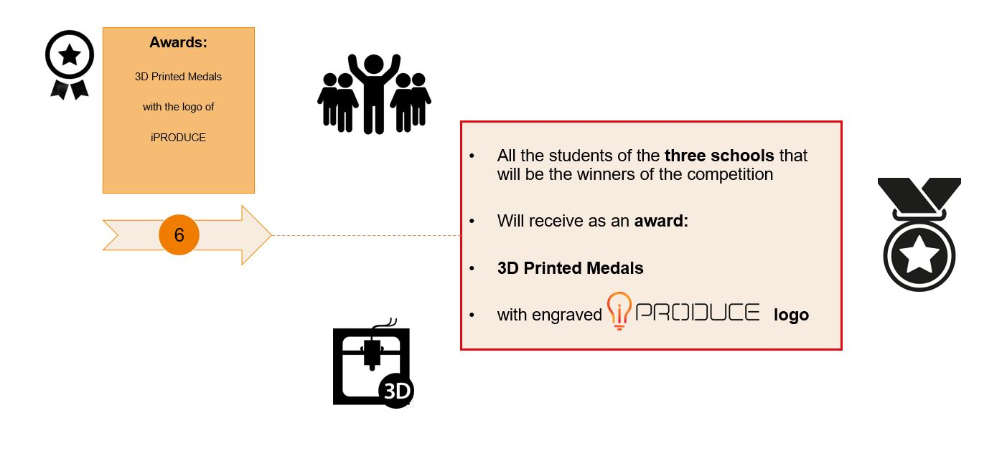

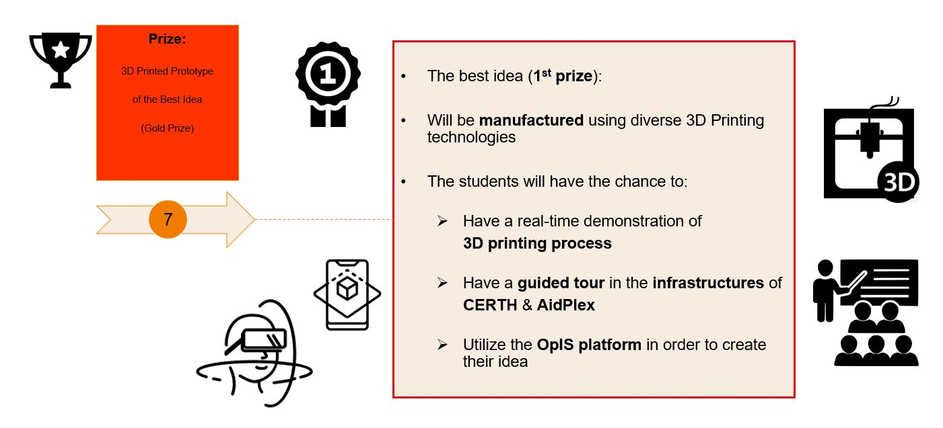

Competition deadlines
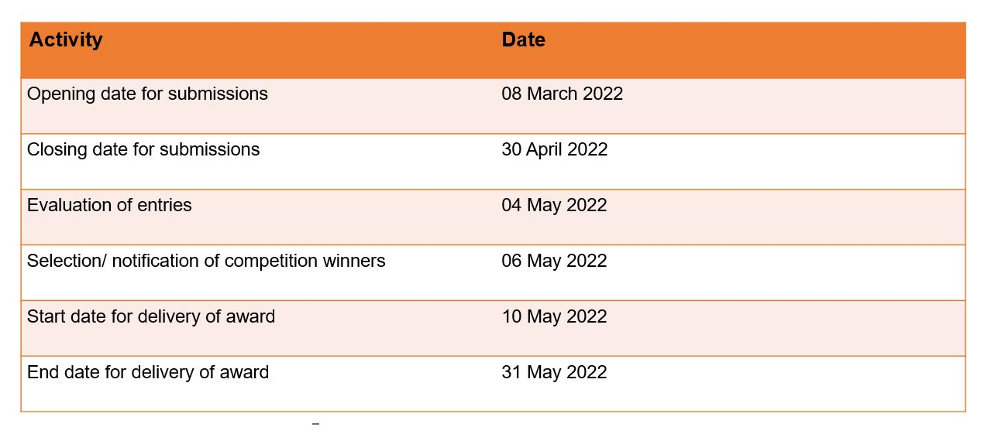

Application Form
The participants are invited to respond to the following questions:

Presentation of the candidate
(Please describe the following: name of school, region, and the number of the students that will participate in the competition)
200- words maximum

Description of the idea
(Which challenge idea have you selected (A) or (B)? Which country among the six European countries (Denmark, France, Germany, Greece, Italy, Spain) that constitute the cMDfs iPRODUCE project, and which monument have you selected and why?)
500- words maximum

Current status of technology in schools
(Are you familiar with 3D Printing technologies, Augmented and Virtual Reality (AR/VR) etc.?)
500- words maximum

Value and impact of the idea related to iPRODUCE project
(Why do you think your design/idea is better than other existing ideas? Why would this design be successful in the selected country?)
500- words maximum

Willingness/motivation
(Describe your willingness/ motivation to participate in the development and the evaluation of the idea in the project, after being selected as the winner of the competition)
500- words maximum

Stage of development
(In which of the following categories do you prefer to participate, after being selected as the winner of the competition?)
- Development and Design of the Idea (Project Planning)
- 3D Design
- 3D Printing
- Other: …………………………………

Contact details of the applicant
Name of responsible teacher/guardian/parent:
Email:
Telephone:
School Name:
Region:
Names of students:

Other terms and conditions
All of the following terms and conditions must be met in order to proceed with your application

- I confirm that responsible teacher/guardian/parent is aware of my participation in the competition
- I confirm that I agree to participate in the evaluations of iPRODUCE methodologies and tools
- I confirm that I have read the specifications and requirements of the competition

Submission and evaluation

Submission of applications
The participants are invites to:
- Select one of the proposed challenge ideas (#A) or (#B)

- Complete the application form (doc. file format)

- Prepare a digital image (scanned or photo in jpeg or .png file format) of the design (sketch) of their idea

- Send all the aforementioned via email to:
- Theodora KONTODINA: kontodinazoli@iti.gr

- Subject of email: “iPRODUCE Open Competition”

The opening day for submissions is 8 March 2022, and the application entries must be submitted until 30 April 2022.

Evaluation process
The evaluation of the entries will be completed on 4 May 2022.

The jury, which will evaluate the proposals of the participants, will be composed of representatives of the Greek iPRODUCE partners and local ambassadors, from the following three entities:

- Center for Research and Technology Hellas (CERTH)

- AidPlex

- Union of Parents & Guardians Association of Primary & Secondary Education, Municipality of Chalkidona

Announcement of results
The results will be announced on 6 May 2022 and will be published on the official website of the project iPRODUCE. Additionally, all the candidates will be informed via email for the result.
The award ceremony will take place in the infrastructures of the laboratory of Additive Manufacturing Unit (AMU) of CERTH/ITI, on Saturday 28 May 2022, at 10:00 am

Contact and information
For more information related to the completion submissions, please contact Theodora Kontodina:

Theodora KONTODINA
Dip. Eng. Production & Management
MSc in Strategic Product Design
Ινστιτούτο Τεχνολογιών Πληροφορικής και Επικοινωνιών (ΕΚΕΤΑ/ΙΠΤΗΛ)

6th Km, Charilaou – Thermi Road
GR. 57001, Thermi, Thessaloniki
Tel.: (+30) 6976290906
kontodinazoli@iti.gr

https://www.certh.gr/

